Twitter Topic Summarization
Abstract:
In a micro-blog such as twitter there is a wide array of tweets on each topic of interest according to the user.The tweets are noisy,conversations,express opinions and suggestions and may notify of a change of events in the current trend.
In order to enable users to quickly view a summary about a topic searched , a system is proposed in which given an input query topic, the best relevant tweets are retrieved by the system using speech act recognition which is a multiclass classification problem solved using the word based linguistic features and features based on twitter .The unwanted tweets are ignored and then an abstract summary is formed. Summarisation is done based on stream-based and semantic-based.Stream based is that a collection of tweets are collected and are split up into different sets based on the timing of the tweet.Due to some hindraces a tweet on a sub topic may be put up in different set of tweets and so a semantic-based subtopic detection and summarization is necessary.After finding out the subtopics ,measure of Local Relevance,Global relevance and Crowding endorsement are also found out to enhance the summarizer.
Domain: Machine Leaning, Natural Language Processing
Problem Statement:
To build a system that helps to get a topic oriented summarization from tweets and gains information from them .In this system we plan on using basic speech acts like question, suggestion, comment, suggestion, miscellaneous to find the tweets containing information and using relevance between the tweets to minimize the redundant information.

Applications:
It could be used to generate abstractive summaries for news articles, technical articles, and briefings.
It could be used to find the general opinion of People which would help the world in a variety of ways

Literature Review:
- Automatic Twitter Topic Summarization With Speech Acts [Renxian Zhang, Wenjie Li, Dehong Gao, and You Ouyang]
This paper proposes a speech act-based approach to Twitter topic summarization. The approach to topic summarization is employed in three Core modules: recognizing speech acts in tweets(using an SVM based on linguistic word features and features because of twitter), extracting speech act-guided key words/phrases(finding out the important key words/phrases based on speech acts) and generating abstractive summaries by generating a score based on hash topic information and also creation of templates for each of the speech acts and deriving the ngrams from the tweet for the template.

- Sequential Summarization: a Full View of Twitter Trending Topics [Dehong Gao, Wenjie Li, Xiaoyan Cai, Renxian Zhang and You Ouyang]

Sequential summarization, which aims to provide a serially ordered short sub-summaries for a trending topic in order to provide a complete story about the development of the topic while retaining the order of information presentation. Two approaches, i.e., stream-based and semantic-based approaches, are developed to detect the important subtopics within a trending topic.Stream based approach is done by splitting up tweets into different sets based on time surges.Semantic based sub topic detection is done because a sub topic can also be distributed into different sets.Thus measures of Local Relevance,Global relevance ,Crowding Endorsements are included.In addition,it proposes three new measures to evaluate the position-aware coverage, sequential novelty and sequence correlation of the system-generated summaries.
Then a short sub-summary is generated for each subtopic.

- Comparing Twitter Summarization Algorithms for Multiple Post Summaries [David Inouye* and Jugal K. Kalita+]

In this paper, a Frequency based summarizer (involving Sum Basic & Hybrid TF-IDF) was proved to provide better results than the other 6 summarizer’s used. Eight different summarizers: random, most recent, MEAD, TextRank, LexRank, cluster, Hybrid TF-IDF and SumBasic. A threshold was used to find out similarity.

- TweetMotif: Exploratory Search and Topic Summarization for Twitter [Brendan O’Connor, Michel Krieger,David Ahn]

In this paper, TweetMotif Search application groups messages by statistically unlikely phrases that co-occur the themes of the conversation. Also the text analysis system also clusters near duplicates and uses other techniques to improve your view of the twitter lands. TweetMotif to deflate rumors, uncover scams, summarize sentiment, and track political protests in real-time.
- Summarizing Microblogs Automatically[Beaux Sharifi, Mark-Anthony Hutton, and Jugal Kalita]
A short one line summary of a topic based on all the tweets that are related to that topic based on a PR(Phrase Reinforcement)algorithm. First the most talked about topic is found using the most occurring phrase or word and it can also be found based on retweet count. After finding out the phrase they filter out spam or irrelevant data. After that a graph is formed and PR algorithm is used to form a one line summarizer.
- Multiple Post Microblog Summarization[David Inouye]
In this paper they have first clustered the tweets using clustering algorithms like k means, k bisecting means algorithms and have clustered tweets based on sub topics and in these cluster of sub topics a sub summary is developed using various summarization algorithms like hybrid TF-IDF algorithm.
- What Are Tweeters Doing: Recognizing Speech Acts in Twitter[Renxian Zhang; Dehong Gao; Wenjie Li]
This paper does multi class classification of the various speech acts in twitter. It involves design of a feature set based on cue words and phrases, non cue words, character based and annotation based. The training data was taken based on topic level, the whole twitter dataset and category level.

Block Diagram
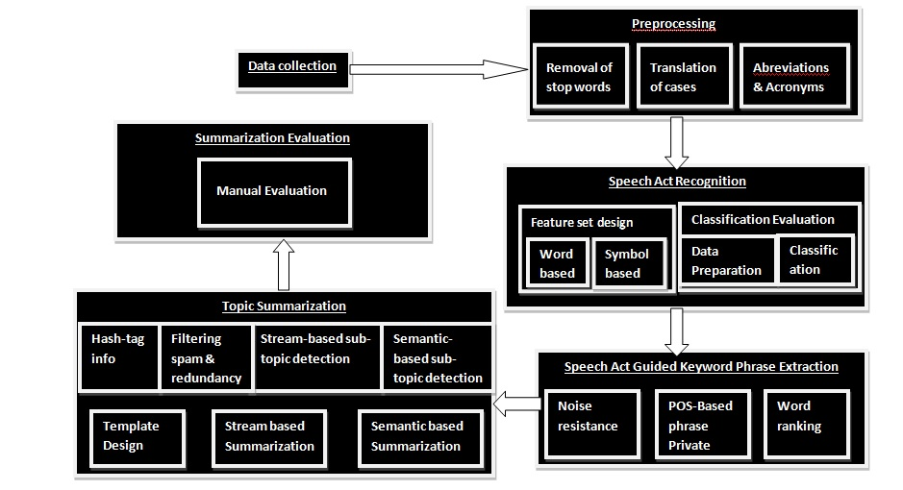

References:
- Renxian Zhang, Wenjie Li, Dehong Gao, and You Ouyang, “Automatic Twitter Topic Summarization With Speech Acts”, Audio, Speech, and Language Processing, IEEE Transactions on (Volume:21 , Issue: 3 ), March 2013.
- Dehong Gao, Wenjie Li, Xiaoyan Cai, Renxian Zhang and You Ouyang, “Sequential Summarization: a Full View of Twitter Trending Topics”, Audio, Speech, and Language Processing, IEEE Transactions on (Volume:PP , Issue: 99 ) September 2013.
- David Inouye* and Jugal K. Kalita+, “Comparing Twitter Summarization Algorithms for Multiple Post Summaries”, Privacy, security, risk and trust (passat), 2011 ieee third international conference on and 2011 ieee third international conference on social computing (socialcom), October 2011.
- Brendan O’Connor, Michel Krieger,David Ahn, “TweetMotif: Exploratory Search and Topic Summarization for Twitter”, 2010.
- Beaux Sharifi, Mark-Anthony Hutton and Jugal Kalita, “Automatic Summarization of Twitter Topics”, University of Colorado at Colorado Springs, 2010
- B.Sharifi, M.-A. Hutton, and J. Kalita, “Experiments in microblog summarization” in Proc. IEEE 2nd Int. Conf. Social Comput., 2010.
- Guofeng Zhu, Zhurong Zhou*, Fengjiao Han and Zhongyun Ying “The Domain Classification Algorithm Based on KNN in Micro-blog”, 2013.
- B. Sharifi, M.-A. Hutton, and J. Kalita, “Summarizing microblogs automatically” in Proc. HLT/NAACL-10, 2010.
- R. Zhang, D. Gao, and W. Li, “What are tweeters doing: Recognizing speech acts in twitter,” in Proc. AAAI-11 Workshop Analyzing Microtext, 2011.

System Design:

- Data Collection:
Using Twitter Api to get the tweets which are used for our Topic Summarization.

2) Preprocessing
a) Abbreviations and acronyms:
A module in which abbreviation of all acronyms which are used in social networking sites like im, 4ever etc is done.
a) Transforming/Changing other features:
A module in which all words are translated into lower cases for better results,email addresses and urls are removed and tagged ,Emoticons are looked up with the database and we find out the sentiment with which the tweet was delivered if possible,Unwanted characters are removed(excess of fullstops) .

3) Speech act Recognition
Feature Set Design:
A module in which all the features which are required to classify between the different speech acts.
- Word based features:
CUE WORD
Using a linguistic word based feature set ,For eg “whether” would mostly signify that the sentence is a question and “could you please” would mostly signify a suggestion.So a list of specific unigrams,bigrams and trigrams are found out which would enhance the classifier.
In addition to this , if the sentence is properly formed , the sentence would be pos tagged and depending on specific grammatical rules,which is highly likely would also help to enhance the classifier.
NON CUE WORD
Feature set based on the abbreviations and acronyms commonly used on the internet like “tq” ,”4ever” etc..Opinion words collected from sentiwordnet.Emoticons could signify the amount of Emotion into the tweet and the postive or negativity of the tweet which could be found out by sentiwordnet.They could also be taken into account for the classification of Sentences.Vulgar word which could be found out with a straight forward word check.These could enhance the classifiers ability to classify correctly.

- Symbol based features:
“?” mostly signifies that the tweet is a question and it could also signify a confused state . ”!” Could signify an exclamatory sentence or an excited state.Twitter Specific symbols are RT(Retweet),@(directed towards a person through acts of dialogue),#(denotes a topic or comment).A RT strongly indicates the presence of a statement.
Classification Evaluation:
- Data Preparation
A suitable data set for a supervised classification algorithm is used.
- Classification:
A module in which tweets are classified in each topic using different feature sets employing SVM algorithm using a linear kernel or logistic regression .A cross validation is done and a feature set is mixed up and used to see which feature set is the best and removal of redundant features .An F1 score can be computed to find out the correctness of the classifier.

4) Speech act guided keyword/phrase extraction
- Noise Resistant Phrase Extraction
In this module we try to extract key words and phrases from the tweets of major speech act types after removing stop words. Extracting the key phrases is formulated as finding frequent n-gram collocations.

- POS based Phrase Extraction:
Statements are about facts, things, people, etc. and suggestions are about actions, activities, etc. Such information can be approximated by part-of-speech (POS) patterns for both words and phrases.

- Phrase/Word Ranking
A module in which we assign a rank to a phrase and see its importance.

5) Topic Summarization:
a) Hash tag info:
Apply a method to use hash tag for information related to the topic by splitting it up.
- Stream-based subtopic detection:
The stream-based subtopic detection then is to identify these peak areas from the tweet stream about a specific topic.
c) Semantic-based subtopic detection:
To identify subtopics from the semantic perspective, semantic-based subtopic detection could be done by a KNN method or another equivalently efficient algorithm to capture subtopics in the tweet stream.
d) Template Design:
Insert the information so far gathered and putting them in slots of a basic template.
- Stream based sequential summarization algorithm:
A summarization algorithm is used to summarize all the sentences so far extracted from the text based on local relevance, global relevance and crowd endorsement by using a cosine similarity formula.
- Semantic based summarization algorithm:
We use the output probabilistic relationships between tweets and subtopics to assign each tweet to the subtopic that it most likely belongs to. Then the subtopics are ordered by the mean timestamp of the tweets in the corresponding subtopics. A score is computed for each sentence from the corpus collected and selected .Then the tweets with the highest scores are selected for each subtopic. MMR is used to remove redundancy in the generation of each sub-summary in both cases. For each tweet to be selected into sub-summary, it is compared against the tweets that are already selected in the previous sub-summaries. The tweet is selected only when it is considered not significantly overlapping any previously selected tweets.

Final Work to be done:
Given a topic a user should view an abstract summary of the Topic.

Input:

RT @IBNLivePolitics: Delhi: Hit by Vijay Goel's rebellion, BJP defers naming CM candidate http://ibnlive.in.com/news/delhi-hit-by-vijay-goels-rebellion-bjp-defers-naming-cm-candidate/429510-37-64.html …

BJP releases list of candidates for Chhattisgarh assembly elections http://www.ndtv.com/article/assembly-polls/bjp-releases-list-of-candidates-for-chhattisgarh-assembly-elections-434814 …

BJP's Delhi CM candidate: Vijay Goel stakes claim http://dnai.in/bLFy pic.twitter.com/duLtIGde4C

Delhi BJP's Vijay Goel threatens to quit if not made chief ministerial candidate

News Flash: Delhi BJP president Vijay Goel storms out of meet held to take a decision on the party's Delhi CM candidate

Output:

Delhi BJP President Vijay Goel storms out of meet held to take a decision on the party’s Delhi Chief Ministerial candidate. Hit by his rebellion BJP defer naming Chief Ministerial candidate. He threatens to quit if not made Chief ministerial candidate.

